**Strategy for**

**The National Research Centre for the Working Environment**

**2021-2024**

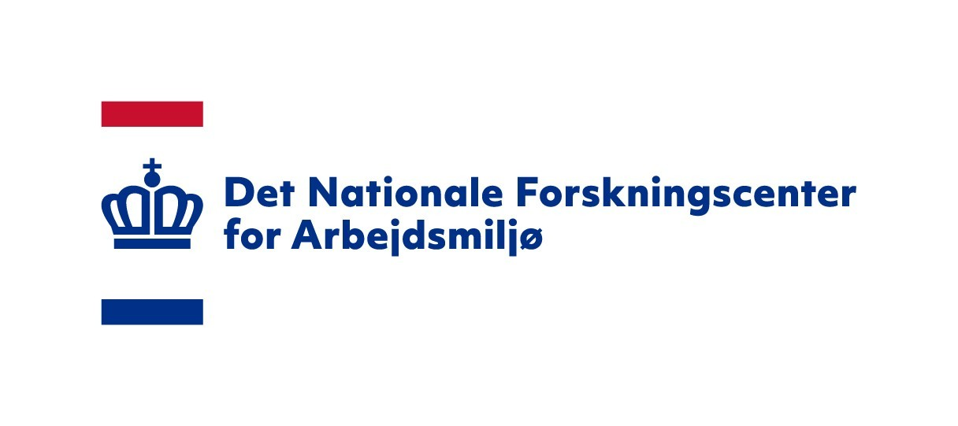

**March 2021**

# The strategic framework

Following the political settlement on the working environment in April 2019, a tripartite agreement was signed in December 2020 regarding a set of new national goals for working environment efforts in Denmark. The national goals are as follows:

* A strong safety culture in workplaces, with fewer people suffering occupational accidents
* Safe and healthy work with chemistry, with fewer people being exposed to hazardous chemical substances in the workplace
* A safe and healthy ergonomic working environment, with fewer people being subjected to significant physical strains
* A safe and healthy psychological working environment, with fewer people being subjected to significant psychological strains

The national goals will also be concretised in specific industry-oriented goals in those industries where a consensus exists that risks and strains are significant and widespread. The agreement contains an expectation that the NFA’s research will be aimed at supporting the realisation of the policy goals over the coming 10 years. The agreement states that it is intended to support Sustainable Development Goal 3 (health and well-being) and 8 (decent jobs and economic growth).

Furthermore, the agreement notes a general need for knowledge and research on the relationship between systematic working environment efforts and a healthy and safe working environment in workplaces. Additionally, the agreement calls for action-oriented research on the relationship between risk factors, prevention and health effects.

The agreement also calls for developing a greater foundation of knowledge on specific areas. In relation to the ergonomic working environment, there is a need for more knowledge and research on the basis of objective surveys on the relationship between exposures and health impact. In relation to the chemical working environment, there is a need for more knowledge and research on exposure levels of chemical substances in the working environments of Danish workplaces. In relation to the psychosocial working environment, there is a need for more knowledge and research on the relationship between risk factors and health. For example, this could include high workloads and time pressure, high emotional demands as well as vague and conflicting demands. More research on work-related stress will accordingly also prove relevant.

Furthermore, the parties to the political settlement approved a national working environment research strategy with a stated intent for the research to (1) support the achievement of the national goals, (2) focus on working environment problems with the greatest prevalence, seriousness and potential for improvement, (3) contribute to filling in knowledge gaps on working environment issues, and (4) in extension thereof, develop more types of research (evidence types), (5) including a greater focus on research on the impact of various interventions.

Additionally, it is expected that (6) working environment research should be application-oriented, both in relation to policy and practice, (7) that solutions must be able to be identified, tested, documented and disseminated, and that (8) working environment research should consider the economic potential of remedying significant working environment issues. (9) Finally, working environment research is expected to expand interdisciplinary research with existing and new research environments, both at home and abroad.

In the political agreement on the right to early retirement (10), funding has been allocated to the NFA building up a new research area on working environment economics in the coming years.

As part of its strategy development work, the NFA has consulted its key stakeholders and noted expectations that (11) the NFA should continue to conduct research within - and between - its core areas; chemistry and microbiology, psychosocial and ergonomic working environment, and occupational accidents and safety culture.

Finally, evaluations have been conducted on the NFA’s scientific and societal impact in 2020-2021. (12) The international evaluation panel concluded that the scientific quality varies from very high to excellent. (13) The evaluation of the societal impact concludes that the NFA’s research has been impactful both in relation to authorities (upstream) as well as bridge builders and workplaces (downstream). The evaluation also concludes that there exists room for improvement in relation to creating a greater societal impact.

# Overall purpose

Based on the national goals, the national research strategy, evaluations of the NFA’s scientific and societal impact and feedback from stakeholders, the NFA has formulated a mission, vision and its desired long-term societal impact.

*Mission:* The NFA researches, disseminates, trains researchers and advises authorities with a view to contributing to a healthy and safe working environment.

*Vision:* The NFA produces research-based knowledge of a high international quality which can be used by workplaces, authorities and other actors in their efforts to create a good working environment.

*Long-term societal impact:* The NFA’s long-term impact goals are as follows:

* The NFA contributes - together with other actors - to identifying, investigating, preventing and managing current and future challenges and possibilities in Danish working environments.
* The NFA’s research supports the fulfilment of the national working environment goals.
* The NFA’s research contributes to realising the national research strategy for the working environment.
* The NFA’s research creates a societal impact by supporting

the knowledge foundation for the development of the working environment in Denmark.

# A three-track strategy

The strategy should be regarded as an extension of and as being in line with the national initiatives that the NFA is expected to actively contribute towards. This is illustrated in the figure below, which shows the relationship to two of the SDGs, which are also mentioned in the agreement on the national goals for working environment efforts. The national goals for working environment efforts, combined with the national research strategy, make up the core benchmarks of the NFA’s institutional strategy, including the identified knowledge needs. This strategy will accordingly form the framework for the NFA’s research programmes and other implemented strategies, such as the NFA’s communication strategy.

The strategy relates to the NFA’s *general operations,* including *what* the NFA seeks to achieve (the NFA’s societal impact), *where* to direct its research efforts (research areas), *how* to conduct its research (types of evidence and methods) and *how* to achieve that (organisational sustainability). The strategy takes into account the consequences of the political settlement on the working environment as well as the general financial conditions to which the NFA’s research is subject.

The strategy therefore consists of three tracks:

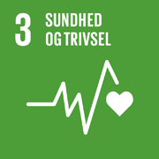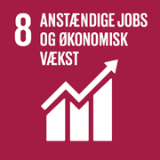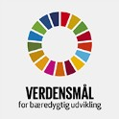

The Sustainable Development Goals

1. More innovative research
2. Greater societal impact
3. Enhanced organisational sustainability

The objectives within each track are elaborated upon below. Each objective comes with key performance indicators that allow us to monitor progress towards achievement of that objective.

National goals for working environment efforts

National strategy for working environment research

# Track 1. More innovative research

The NFA’s research programmes

Chemical working environment

Ergonomic working environment

Psychosocial working environment

Occupational accidents and

safety culture

Working environment economics and digital solutions

The NFA’s institutional strategy

The 2020 international evaluation of the NFA’s scientific quality found that the NFA’s quality of research ranges from very high to excellent. Our ambitions do not stop here, however. We need to improve the quality of our research even further.

The NFA’s research is often conducted in collaboration with research environments in Denmark and abroad. As recommended in the evaluation of the NFA’s scientific impact, these collaborations must be maintained and expanded through entering into strategic research collaborations and exchanges that can contribute to further methodological innovation and pioneering research on the working environment of today and the future.

Research to Practice strategy

Communication strategy

*Figure 1 - Strategic levels*

A special feature of the NFA is its considerable breadth of research. The potential that exists in interdisciplinary collaborations must be explored and harnessed, internally at the NFA as well as in partnership with other research environments. This is also in line with the recommendations from the evaluation of the NFA’s scientific impact, the intentions of the national research strategy and the agreement on the national goals for working environment efforts.

As mentioned, the NFA’s research must be in line with the national research strategy. This means that the NFA’s research must not only seek to address the knowledge needs identified in the national goals, but also future working environment conditions.

The NFA will continue to conduct research on the working environment within its core areas: chemistry and microbiology, psychosocial and ergonomic working environment and safety culture and occupational accidents.

These are broad research fields, however, which is why prioritising the areas in which the NFA aspires to be an international leader is necessary. Objectives have been established to that end, and the indicators reflect the recommendation in the evaluation of the NFA’s scientific impact. In addition to the indicators mentioned, the NFA will develop methods to document the quantity and quality of our research.

Based on the agreement on the national goals, along with the identified research needs, consultations with stakeholders and an analysis of the working environment, the following prioritisation of research themes has been made for each research area. The ambition is to generate more knowledge on relevant working environment topics in the current and future labour market:

* *Chemistry and microbiology:* This research will especially prioritise the development, implementation and evaluation of preventive interventions. These interventions will be based on risk assessments, which will in turn be based on research on relationships between chemical and microbiological exposures and health in Danish workplaces, as well as knowledge of which substances and exposures are the most hazardous and prevalent. This research will also include the development and validation of risk assessment tools, new survey methods and standardisation, intervention and international knowledge acquisition.
* *Psychosocial working environment:* This research will especially prioritise the development, implementation and evaluation of preventive interventions aimed at improving the psychosocial working environment. These interventions will be based on research on causal relationships between the most important psychosocial strains and health, including combinations of positive and negative psychosocial factors in the working environment and organisation of work, scope and working hours. The purpose is to prevent psychological strains as well as to include and retain more people in the labour market.
* *Ergonomic working environment and musculoskeletal disorders:* This research will especially prioritise the development, implementation and evaluation of working environment interventions that contribute

to preventing reduced working capacity while promoting long, healthy working lives. Special focus areas include organisation and arrangement of healthy work, knowledge on combinations of working environment exposures and their consequences as they appear in actual workplace conditions. To aid in this research, we will also focus on developing technologies to perform measurements on the ergonomic working environment.

* *Occupational accidents and safety culture:* This research will especially prioritise the development, implementation

and evaluation of interventions with a view to ensuring that effective instruments are adopted in practice and strengthening systematic prevention efforts in workplaces. This research area will thereby contribute to a safe and healthy working environment where fewer people fall victim to occupational accidents.

* *Working environment economics:* This research will especially prioritise the development of models for the economic evaluation of working environment interventions and assessing the economic

consequences (for society, industries and businesses) of working environment interventions. The models are intended to provide more knowledge on interventions at the policy, industry and business level and their economic potential.

This research is envisaged to take place in close collaboration with the area’s stakeholders as well as relevant national and international research environments, with a view to ensuring relevancy and adaptation of the research processes and products, thereby increasing the likelihood of subsequent adoption and application and thus making a societal impact. The area’s stakeholders must therefore be involved before, during and after the research process. This reflects the recommendation in the evaluation of the NFA’s societal impact.

To increase the applicability and spread of new solutions, the NFA will further strengthen its intervention and implementation research, as recommended in the evaluation

of the NFA’s societal impact. The NFA will also maintain a high standard of research on causal relationships, as recommended in the evaluation of the NFA’s scientific impact.

At the same time, the NFA’s research must develop new disciplines and methods that can build upon and strengthen its existing and interdisciplinary research. This research will pave the way for different types of research into relationships, instruments and the implementation of instruments. The NFA will also build a research environment on working environment economics while actively developing and employing new digital technologies that can enrich existing research, including IoT, Big Data analytics, etc. Such technologies can be used for data collection, analysis or products used in the workplace. These ambitions cut across the research programmes, as illustrated in the figure below.



Research on relationships

Research on instruments

Research on implementation

Working environment economics

Digital technologies

Psychosocial

MSB

Occupational accidents and safety culture

Chemistry

*Figure 2 - Types of research and areas*

Overall goal:

* The NFA must produce more innovative research that is used to maintain and develop healthy and safe workplaces

The following specific objectives have been set:

1. The NFA is recognised as internationally leading (top 3) within up to four selected research themes per research area.
2. The NFA has developed internationally recognised models for the economic evaluation of working environment interventions.
3. The NFA’s research portfolio of interventions - with associated impact, process and economic evaluations - must increase by 20% during the strategy period.
4. The NFA’s research projects must be based on stakeholder consultations.

# Track 2. Greater societal impact

Scientific quality is not only about making a scientific impact; it is, to a great extent, also about making a societal impact.

The NFA defines its societal impact as the working environment-related, health-related, political, social and/or economic improvements that are wholly or partly, directly or indirectly, impacted by the NFA’s research and performance. Our goal is to identify this impact at the individual, group, management and organisational level.

The evaluation of the NFA’s societal impact in 2020 shows that the NFA can improve its impact. This applies to both upstream - in relation to policy development - as well as downstream, in relation to workplaces.

The NFA must therefore increase its societal impact.This must be done without compromising the scientific quality and credibility of the NFA’s research, which is the foundation upon which we are building.

A greater societal impact can be achieved *partly* by systematising relationships to and increasing the involvement of the area’s key stakeholders in the research process, and *partly* through effective communication.

|  |  |
| --- | --- |
| 3 | Change: Impact cases - long term Impact cases describe the more complicated dissemination and processing processes and how knowledge has resulted in change. |
| 2 | Application: Impact measurement - medium termThe NFA’s Impact measurement instrument allows us to conduct an annual survey to see how our knowledge has been used, applied and put into practice. |
| 1 | Dissemination: Tracking of SoMe - short term  The NFA tracks how knowledge spreads on social media from a day-to-day perspective. It gives us a picture of what matters to and engages users. |

Our dialogue with stakeholders is intended to inform the NFA’s research, directing it at the working environment problems and possibilities - both short- and long-term - that the field considers most important, as well as help us identify the potentials of finding solutions to those problems and harnessing those possibilities. This will result in a greater societal impact.



*Figure 3 - The NFA’s documentation of its societal impact*

In extension thereof, the NFA shall strive to become an international beacon in creating and documenting societal impact. Accordingly, the NFA will develop a systematic documentation of its societal impact in the short, medium and long term. This includes monitoring the spread of NFA research on social media, using a quantitative impact instrument and impact cases. The later documents - through quantitative and qualitative data - how the knowledge gained from one or several specific research projects has resulted in concrete long-term changes. Currently, no quantitative instruments have been developed to document long-term impact.

The ambition is to make a greater societal impact will partly be supported through internal competence and capacity building and partly through a communication strategy. The goal is

for the NFA to focus its dissemination of research and translate its research findings into different types of products and processes that the individual target groups can better apply to practice. The NFA will to a greater extent target and distribute its research through digital platforms and tailor the dissemination of its research to specific target groups based on data on effective communication. Finally, the NFA will strive to expand its reach by seeking out new actors that can serve as bridge-builders and working in coordination with the Danish Working Environment Authority and the industry associations for working environment issues (BFAs). The priorities in the communication strategy reflect many of the recommendations contained in the evaluation of the NFA’s societal impact.

Overall goal:

* The NFA must achieve a greater societal impact The following specific objectives have been set:

1. During the strategy period, the NFA must increase its reach on digital media by 80%.
2. During the strategy period, the NFA must improve its societal impact by 20%.
3. The NFA must have at least eight impact cases that document its societal impact on policy development and in workplaces.
4. The NFA must become a recognised thought leader within research-to-practice approaches and research, both nationally and abroad.

# Track 3. Enhanced organisational sustainability

The evaluation of the NFA’s scientific quality showed that we are performing our core function at a very high level. This is to no small extent due to the strong competences within the organisation, which we must retain and further develop. The NFA wants to be an exemplary workplace, where work performance and working environment go hand-in-hand. This requires a solid foundation, both now and in the future.

To ensure our organisation is sustainable and continues to produce research at the highest international level, the NFA must strengthen its financial foundation. The NFA must therefore grow and increase its external research funding as well as spread the sources of funding across more prioritised funds. Finally, the NFA must improve its resource utilisation of human and technological capital.

Realising the above objectives in the other tracks will require investments in strategic competence development of employees, modernisation of systems and efficient working processes that support the achievement of the objectives.

It will be necessary to strengthen a number of support functions in relation to essential management tasks, including the GDPR, good government services and organisational development.

The NFA must continue to develop as an exemplary and attractive workplace that assumes social responsibility in relation to fostering an inclusive labour market, focusing also on good management and collaborative relationships.

For a number of years, the NFA has been focused on developing climate-friendly solutions in areas such as waste sorting, ventilation, lighting and heating. The NFA will continue to contribute to the Government’s (expected) action plan for the UN SDGs, focusing in particular on opportunities to reduce its climate footprint and thereby contribute to the green agenda.

Overall goal:

* The NFA must strengthen its organisational sustainability The following specific objectives have been set:

1. The NFA must increase its research funding. Over the coming four years, research funding must grow to DKK 50, 55, 60 and 65 million.
2. At least 50% of research funding must come from sources other than the Working Environment Research Fund.
3. The NFA must contribute to the realisation of the Government’s climate action plan.

# Strategy execution

This strategy is ambitious and requires the NFA to significantly develop its organisation in a variety of areas, including capacity, workflows, system support, external relations and external communication. This will require building upon a number of core processes (the NFA’s research) and auxiliary processes (that support the NFA’s research). A major aspect of these development efforts will affect the auxiliary processes, and the NFA’s core processes only be directly affected to a lesser extent. The identified development efforts have been operationalised in Figure 4 below, which also shows the relationship to the strategic objectives. The figure is not intended to depict an exhaustive overview of the NFA’s work. The development efforts will be organised with the involvement of employees with a view to creating the greatest possible value. An overview has also been developed for the scheduled completion of the work (see Figure 5, Figure 6, Figure 7). Finally, Figure 8 provides an overview of the relationships between the objectives and KPIs.

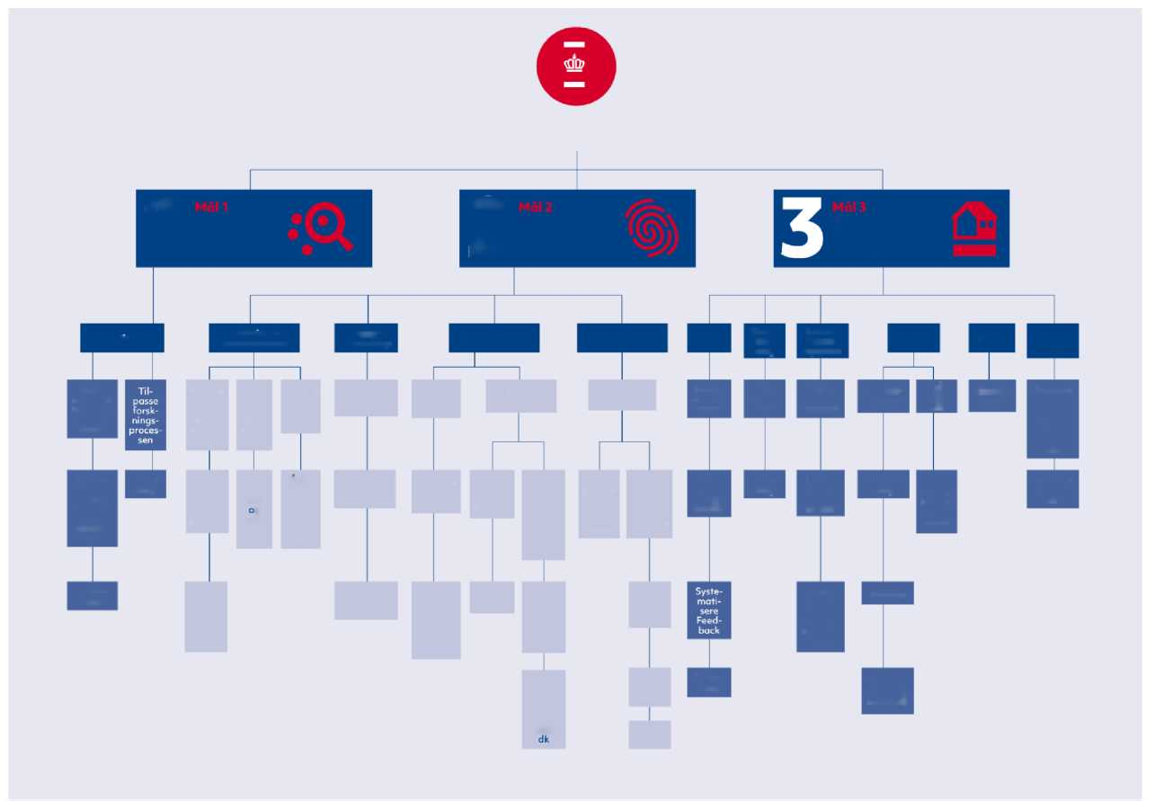

*Figure 4 - Overview of work packages in the strategic execution plan.*

The NFA researches, disseminates, trains researchers and advises authorities with a view to contributing to a healthy and safe working environment

Relationships

Development of documentation

Thought leadership

Communication

Competences

HR

Winning  
grants

Capacity utilisation

Operations

Climate

Governance

Systematising relationship stakeholders

System support of stakeholder  
relationships

Roll-out

Running  
analyses  
and improvements

Roll-out

Relaunch of mitarbejdsmiljø.

dk

R2P tools

Relaunch of www.nfa.dk and other websites

R2P specialists

Roll-out

Tools  
and concepts  
for other channels

Presentations and seminars

Scientific articles

Staff training

Tools  
and concepts for internal channels and content

Integration of  
performance contracts

Competence development programme

Conference papers

Target group analysis

Digital and

SoMe plan

Job descriptions

KAM  
initiative

Expiration procedure

Capacity analysis

New ERP system

Develop

MIS

Action plan

Describe governance between ME and  
board

Revise  
statutes

Adapt  
internal operating meetings

Setup

Roll-out of time standards for tasks

Roll-out

On-boarding packages

Roll-out  
of equipment registration

Training

Portfolio management roll-out

Roll-out

1

Goal 3

Enhanced organisational sustainability

2

Goal 2

Greater societal impact

Goal 1

More innovative research

Impact Case  
concept

Plan for measuring SoMe impressions

Impact measurement instrument

**Adapt  
the  
research  
  
process**

Annual documentation and improvement

Annual  
measurement and  
improvements

Establish  
data infrastructure

Channel and product analyses

**Systematise  
feedback**

Roll-out

*Figure 5 – Gantt diagram of work packages for goal 1*

|  |  |  |  |  |  |  |  |  |  |  |  |  |  |  |  |  |
| --- | --- | --- | --- | --- | --- | --- | --- | --- | --- | --- | --- | --- | --- | --- | --- | --- |
| Work package | Deadline | | | | | | | | | | | | | | | |
| 1 Goal 1 More innovative research | 2021  Q1 | 2021  Q2 | 2021  Q3 | 2021  Q4 | 2022  Q1 | 2022  Q2 | 2022  Q3 | 2022  Q4 | 2023  Q1 | 2023  Q2 | 2023  Q3 | 2023  Q4 | 2024  Q1 | 2024  Q2 | 2024  Q3 | 2024  Q4 |
| 1.1 Relationships |  |  |  |  |  |  |  |  |  |  |  |  |  |  |  |  |
| 1.1.1 Systematise stakeholder relations |  |  |  |  |  |  |  |  |  |  |  |  |  |  |  |  |
| 1.1.2 System support of stakeholder relations |  |  |  |  |  |  |  |  |  |  |  |  |  |  |  |  |
| 1.1.3 Roll-out |  |  |  |  |  |  |  |  |  |  |  |  |  |  |  |  |

*Figure 6 – Gantt diagram of work packages for goal 3*

|  |  |  |  |  |  |  |  |  |  |  |  |  |  |  |  |  |  |
| --- | --- | --- | --- | --- | --- | --- | --- | --- | --- | --- | --- | --- | --- | --- | --- | --- | --- |
| Work package |  | Deadline | | | | | | | | | | | | | | | |
| 1 Goal 1 Greater societal impact |  | 2021  Q1 | 2021  Q2 | 2021  Q3 | 2021  Q4 | 2022  Q1 | 2022  Q2 | 2022  Q3 | 2022  Q4 | 2023 Q1 | 2023  Q2 | 2023  Q3 | 2023  Q4 | 2024  Q1 | 2024  Q2 | 2024  Q3 | 2024  Q4 |
| 2.1 Development of documentation |  |  |  |  |  |  |  |  |  |  |  |  |  |  |  |  |  |
| 2.1.1 Plan for measuring SoMe impressions |  |  |  |  |  |  |  |  |  |  |  |  |  |  |  |  |  |
| 2.2 Establish data infrastructure |  |  |  |  |  |  |  |  |  |  |  |  |  |  |  |  |  |
| 2.2.1 Running analyses and improvements |  |  |  |  |  |  |  |  |  |  |  |  |  |  |  |  |  |
| 2.3 Impact measurement instrument | |  |  |  |  |  |  |  |  |  |  |  |  |  |  |  |  |
| 2.3.1 Annual measurement and improvements | |  |  |  |  |  |  |  |  |  |  |  |  |  |  |  |  |
| **2.4** **Impact Case concept** | |  |  |  |  |  |  |  |  |  |  |  |  |  |  |  |  |
| 2.4.1 Annual documentation and improvements | |  |  |  |  |  |  |  |  |  |  |  |  |  |  |  |  |
| 2.5 Thought Leadership | |  |  |  |  |  |  |  |  |  |  |  |  |  |  |  |  |
| 2.5.1 Conference papers | |  |  |  |  |  |  |  |  |  |  |  |  |  |  |  |  |
| 2.5.2 Scientific articles | |  |  |  |  |  |  |  |  |  |  |  |  |  |  |  |  |
| 2.5.3 Presentations and seminars | |  |  |  |  |  |  |  |  |  |  |  |  |  |  |  |  |
| 2.6 Communication | |  |  |  |  |  |  |  |  |  |  |  |  |  |  |  |  |
| 2.6.1 Target group analysis | |  |  |  |  |  |  |  |  |  |  |  |  |  |  |  |  |
| 2.6.2 Channel and product analyses | |  |  |  |  |  |  |  |  |  |  |  |  |  |  |  |  |
| 2.6.3 Tools and concepts for other channels | |  |  |  |  |  |  |  |  |  |  |  |  |  |  |  |  |
| 2.6.4 Digital and SoMe plan | |  |  |  |  |  |  |  |  |  |  |  |  |  |  |  |  |
| 2.6.5 Employee training | |  |  |  |  |  |  |  |  |  |  |  |  |  |  |  |  |
| 2.6.6 Roll-out | |  |  |  |  |  |  |  |  |  |  |  |  |  |  |  |  |
| 2.6.7 Tools and concepts for internal channels and content | |  |  |  |  |  |  |  |  |  |  |  |  |  |  |  |  |
| 2.6.8 Relaunch of [www.nfa.dk](http://www.nfa.dk) and other websites | |  |  |  |  |  |  |  |  |  |  |  |  |  |  |  |  |
| 2.6.9 Relaunch of mitarbejdsmiljø.dk | |  |  |  |  |  |  |  |  |  |  |  |  |  |  |  |  |
| 2.7 Competences | |  |  |  |  |  |  |  |  |  |  |  |  |  |  |  |  |
| 2.7.1 Job descriptions | |  |  |  |  |  |  |  |  |  |  |  |  |  |  |  |  |
| 2.7.2 Integration of performance contracts | |  |  |  |  |  |  |  |  |  |  |  |  |  |  |  |  |
| 2.7.3 Competence development programme | |  |  |  |  |  |  |  |  |  |  |  |  |  |  |  |  |
| 2.7.4 R2P specialists | |  |  |  |  |  |  |  |  |  |  |  |  |  |  |  |  |
| 2.7.5 R2P tools | |  |  |  |  |  |  |  |  |  |  |  |  |  |  |  |  |
| 2.7.6 Roll-out | |  |  |  |  |  |  |  |  |  |  |  |  |  |  |  |  |

*Figure 7 – Gantt diagram of work packages for goal 2*

|  |  |  |  |  |  |  |  |  |  |  |  |  |  |  |  |  |
| --- | --- | --- | --- | --- | --- | --- | --- | --- | --- | --- | --- | --- | --- | --- | --- | --- |
| Work package | Deadline | | | | | | | | | | | | | | | |
| Enhanced organisational sustainability | 2021  Q1 | 2021  Q2 | 2021  Q3 | 2021  Q4 | 2022  Q1 | 2022  Q2 | 2022  Q3 | 2022  Q4 | 2023  Q1 | 2023  Q2 | 2023  Q3 | 2023  Q4 | 2024  Q1 | 2024  Q2 | 2024  Q3 | 2024  Q4 |
| 3.1 HR |  |  |  |  |  |  |  |  |  |  |  |  |  |  |  |  |
| 3.1.1 Expiration procedure |  |  |  |  |  |  |  |  |  |  |  |  |  |  |  |  |
| 3.1.2 On-boarding packages |  |  |  |  |  |  |  |  |  |  |  |  |  |  |  |  |
| 3.1.3 Systematising feedback |  |  |  |  |  |  |  |  |  |  |  |  |  |  |  |  |
| 3.1.4 Roll-out |  |  |  |  |  |  |  |  |  |  |  |  |  |  |  |  |
| 3.2 Obtaining research funding |  |  |  |  |  |  |  |  |  |  |  |  |  |  |  |  |
| 3.2.1 KAM initiative |  |  |  |  |  |  |  |  |  |  |  |  |  |  |  |  |
| 3.2.2 Roll-out |  |  |  |  |  |  |  |  |  |  |  |  |  |  |  |  |
|  | | | | | | | | | | | | | | | | |
| 3.3 Capacity utilisation |  |  |  |  |  |  |  |  |  |  |  |  |  |  |  |  |
| 3.3.1 Capacity analysis |  |  |  |  |  |  |  |  |  |  |  |  |  |  |  |  |
| 3.3.2 Roll-out of time standards for tasks |  |  |  |  |  |  |  |  |  |  |  |  |  |  |  |  |
| 3.3.3 Roll-out of equipment registration |  |  |  |  |  |  |  |  |  |  |  |  |  |  |  |  |
| **3.4** Operation |  |  |  |  |  |  |  |  |  |  |  |  |  |  |  |  |
| **3.4.1** New ERP system |  |  |  |  |  |  |  |  |  |  |  |  |  |  |  |  |
| **3.4.2** Setup |  |  |  |  |  |  |  |  |  |  |  |  |  |  |  |  |
| **3.4.3** Training |  |  |  |  |  |  |  |  |  |  |  |  |  |  |  |  |
| **3.4.4** Portfolio management roll-out |  |  |  |  |  |  |  |  |  |  |  |  |  |  |  |  |
| **3.4.5** Develop MIS |  |  |  |  |  |  |  |  |  |  |  |  |  |  |  |  |
| **3.4.6** Adapt internal operating meetings |  |  |  |  |  |  |  |  |  |  |  |  |  |  |  |  |
| 3.5 Climate |  |  |  |  |  |  |  |  |  |  |  |  |  |  |  |  |
| 3.5.1 Action plan |  |  |  |  |  |  |  |  |  |  |  |  |  |  |  |  |
| 3.6 Governance |  |  |  |  |  |  |  |  |  |  |  |  |  |  |  |  |
| 3.6.1 Describe governance between ME and board |  |  |  |  |  |  |  |  |  |  |  |  |  |  |  |  |
| 3.6.2 Revise statutes |  |  |  |  |  |  |  |  |  |  |  |  |  |  |  |  |

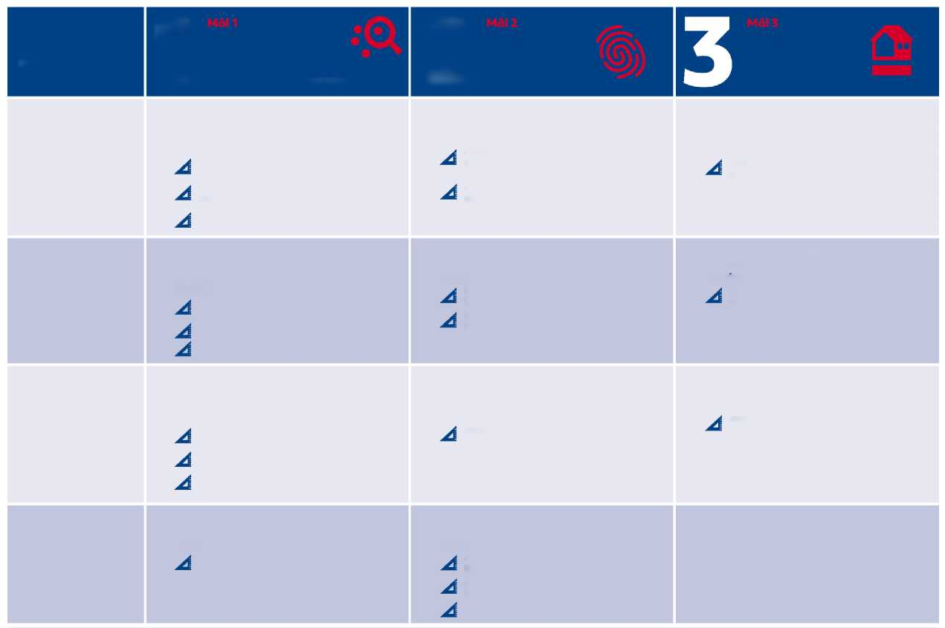Figure 8 - Overview of objectives and KPIs

2

1

Overall goals

Goal 1

The NFA must produce more innovative research that is used to maintain and develop healthy and safe workplaces

Goal 2

The NFA must make a greater societal impact

Goal 3

The NFA must enhance its organisational sustainability

1. The NFA must increase its research funding.

Over the coming four years, research funding must grow to DKK 50, 55, 60 and 65 million.

KPIs:

Specific objectives and KPIs

1. During the strategy period, the NFA must increase its reach on digital media by 80%.

KPIs:

1. The NFA is recognised as internationally leading (top 3) within at least four selected research themes.

KPIs:

Number of views of NFA posts in user feeds on Facebook, Twitter and

LinkedIn.

Number of views of NFA posts in user feeds on Facebook, Twitter and

LinkedIn for each research area

Amount (DKK million) of funding secured from external sources annually

Number of published peer-reviewed articles on selected themes per research area annually

Number of published peer-reviewed articles on selected themes per research area in top five journals annually

Number of citations of thematic articles annually

2. At least 50% of research funding must come from sources other than the Working Environment Research Fund.

KPIs:

2. During the strategy period, the NFA must improve its societal impact by 20%.

KPIs:

2. The NFA has developed internationally recognised models for the economic evaluation of working environment interventions.

KPIs:

Amount of secured funding by external sources

Index score on societal impact instrument annually

Index score on societal impact instrument annually for each research area

Number of tools developed in accordance with research programme

Number of published peer-reviewed articles on working environment economics annually

Number of citations of thematic articles annually

3. The NFA must contribute to the realisation of the Government’s climate action plan.

KPIs:

3. The NFA must have at least eight impact cases that document its impact on policy development and in workplaces.

KPIs:

3. The NFA’s research portfolio of interventions - with associated impact, process and economic evaluations - must increase by 20% during the strategy period.

KPIs:

Score in the NFA’s climate accounts

Number of impact cases annually

Proportion of intervention projects in the NFA’s research portfolio annually

Proportion funds (DKK) allocated to intervention projects in the NFA’s overall research portfolio annually

Proportion of intervention projects in each research area annually

4. The NFA is a recognised thought leader within research-to-practice approaches and research, both nationally and abroad. KPIs:

4. The NFA’s research projects must be based on stakeholder consultations.

KPIs:

Number of published peer-reviewed articles on R2P annually

Number of published peer-reviewed articles on R2P in top five journals annually

Number of citations of R2P articles annually

Proportion of research applications that are based on stakeholder consultations