NOSQ-2002/LONG translation master –
Nordic Occupational Skin Questionnaire

Instructions and examples to the respondent
Framed questions are to be answered by ALL RESPONDENTS. If you answer "no" to a framed question, proceed directly to the next framed question.
Do not omit any framed questions.
1. Tick the box of the answer that is appropriate for you, for example
no 1
yes 2

2. Tick only one box if not otherwise stated in the question, for example
When did you first get eczema on your hands, wrists or forearms?
(one answer in each column if applicable, make your best estimate)
 | Hand eczema | Wrist/Forearm eczema
below 6 years of age | 3 | 3
between 6 and 14 years of age | 4 | 4
between 15 and 18 years of age | 5 | 5
above 18 years of age | 6 | 6

3. If there is an additional question after the answer you select, write your answer
on the given line, for example
yes 2 When was the last time? _____ (year)
(make your best estimate)

4. Answer the questions in numerical order if not otherwise stated after the answer you selected. If there is an indication (move to question...) you should go directly to the indicated question without answering questions in between, for example
no 1 (move to question S1)
yes 2

5. Do not pay attention to the numbers after the boxes. "No" is always 1,
and "yes" is 2. The other boxes are numbered from 3 on.
Instructions to the respondents are written in Italics.
Respondent ID: ____________

G1. Workplace: _____________________________

Department: _____________________________

G2. Are you
a man 1
a woman 2
G3. Year of birth: 19___

G4. Are you at the moment …?
(only one answer)
employed 3
self-employed/private contractor 4
full-time homemaker 5 (move to question A1, page 2)
unemployed 6
student 7 (move to question G8, page 2)
apprentice/trainee 8
on maternity/paternity leave 9
retired/pensioner 10 (move to question A1, page 2)
other, what? _________________ 11

G5. What is your present occupation? ___________________________
Since when? _____ (year)

G6. What is your major activity at work? ___________________________
Since when? _____ (year)

G7. How many hours per week do you work in your main job (on average)? _____ (hours/week)

G8. Do you perform any other paid work regularly?
no 1
yes 2 What kind of work? _________________________________
How many hours per week (on average)? ______ (hours/week)
A1. Have you ever had an itchy rash that has been coming and going for at least 6 months,
and at some time has affected skin creases? (by skin creases we mean folds of elbows,
behind the knees, fronts of ankles, under buttocks, around the neck, ears, or eyes)
no 1
yes 2
don’t know 0

A2. Have you ever had "hay fever" or other symptoms of nasal allergy,
e.g. from pollens or animals?
no 1
yes 2
don’t know 0

A3. Have your eyes ever shown allergic symptoms,
e.g. from pollens or animals?
no 1
yes 2
don’t know 0

A4. Have you ever had asthma?
no 1
yes 2 Has it been diagnosed by a doctor? no 1
yes 2 when? _____ (year)
don’t know 0

D1. Have you ever had hand eczema?
no 1
yes 2

D2. Have you ever had eczema on your wrists or forearms (excluding fronts of elbows)?
no 1 (if you also answered "no" to question D1 move to question U1, page 9)
yes 2

D3. Shade areas on the hands or forearms where you commonly have eczema
(one or more areas)
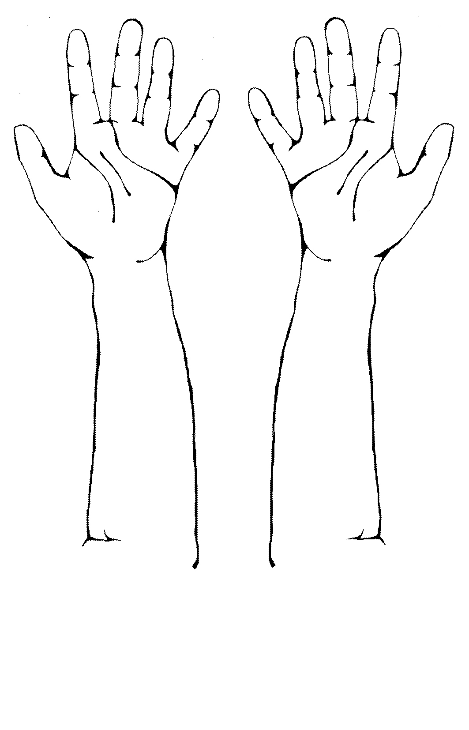
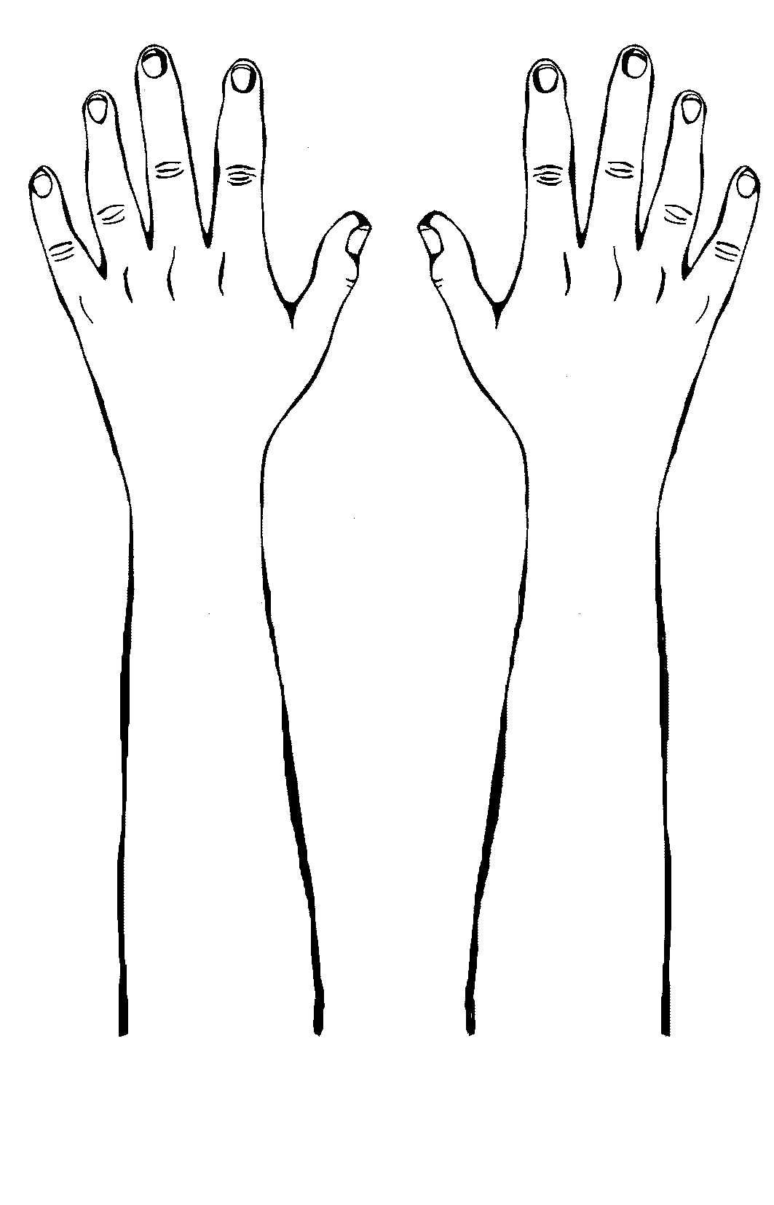

D4. How often have you had eczema on your hands, wrists or forearms?
(one answer in each column if applicable)
Hand eczema Wrist/Forearm eczema

only once and for less than two weeks 3 3
only once but for two weeks or more 4 4
more than once 5 5
(nearly) all the time 6 6

D5. When did you last have eczema on your hands, wrists or forearms?
(one answer in each column if applicable)
Hand eczema Wrist/Forearm eczema

I have it just now 3 3
not just now but within the past 3 months 4 4
between 3-12 months ago 5 5
more than 12 months ago 6 6
In which year was the last time? _____ (year) _____ (year)
(make your best estimate)

D6. When did you first get eczema on your hands, wrists or forearms?
(one answer in each column if applicable, make your best estimate)
 | Hand eczema | Wrist/Forearm eczema
below 6 years of age | 3 | 3
between 6 and 14 years of age | 4 | 4
between 15 and 18 years of age | 5 | 5
above 18 years of age | 6 | 6
In which year did it start?  (make your best estimate) | _____ (year) | _____ (year)
If the hand/forearm eczema started before 18 years of age move to question D10, page 5

 | Hand eczema | Wrist/Forearm eczema
D7. What do you think was the cause of the eczema on your hands, wrists or forearms when it started? (cause) | ________________  ________________ | _______________  _______________
don’t know the cause | 1 | 1
D8. What was your occupation when the eczema started? (occupation) | ________________ | _______________
D9. What were your major activities at work  when the eczema started? (activity) | ________________  ________________ | _______________  _______________

D10. Have you visited a doctor as an adult for your hand or wrist/forearm eczema?
Hand eczema Wrist/Forearm eczema

no 1 1
yes 2 2
When was the last time? (make your best estimate) _____ (year) _____ (year)

D11. During which season do you have most problems with hand or wrist/forearm eczema?
(one or more answers in each column if applicable)
Hand eczema Wrist/Forearm eczema

no seasonal differences 1 1
winter 3 3
spring 4 4
summer 5 5
autumn 6 6

D12. How do you grade your eczema on a scale from 0-10?
(put a mark on the line corresponding to the severity of the eczema)

 | 0 |  |  |  |  |  |  |  |  |  |  |  |  |  |  |  |  |  |  |  |  |  |  |  |  |  | 10
Today
 |  | No eczema |  |  |  |  |  |  |  |  |  |  |  |  |  |  |  |  |  |  | Extremely  bad eczema

 | 0 |  |  |  |  |  |  |  |  |  |  |  |  |  |  |  |  |  |  |  |  |  |  |  |  |  | 10
At worst
 |  | No eczema |  |  |  |  |  |  |  |  |  |  |  |  |  |  |  |  |  |  | Extremely  bad eczema

F1. Have you noticed that contact with certain materials, chemicals or anything else
in your work makes your eczema worse? (one answer in each column if applicable)
Hand eczema Wrist/Forearm eczema

no 1 1
yes 2 2
What? __________________________ __________________________
__________________________ __________________________
don’t know 0 0

F2. Have you noticed that contact with certain materials, chemicals or anything else
outside your work makes your eczema worse? (one answer in each column if applicable)
Hand eczema Wrist/Forearm eczema

no 1 1
yes 2 2
don’t know 0 0

If you answered “no” or “don’t know” in both columns move to question F4, page 8

F3. What do you consider as the most important things outside the workplace
that worsen your eczema? (mark no more than 5 things in each column)
Hand eczema Wrist/Forearm eczema
soap, liquid soap, shampoo,
and other personal hygiene products 2 2
detergents and other household cleaning
and laundry products 2 2
handling of food 2 2
work with wet hands 2 2
frequent hand washing 2 2
protective gloves 2 2
machine maintenance (e.g. cars), handling oils 2 2
construction work, painting, wall-papering,
renovation and decoration 2 2
gardening, handling plants, soil, vegetables,
berries, fruits, etc. 2 2
infections (colds, flu or fever) 2 2
mood, stress 2 2
menstrual periods or other hormonal factors 2 2
other, what? ______________________________ 2 2
______________________________ 2 2
______________________________ 2 2

F4. Does your eczema improve when you are away from your normal work
(for example weekends or longer periods)? (one answer in each column if applicable)
Hand eczema Wrist/Forearm eczema

no 1 1
yes, sometimes 2 2
yes, usually 3 3
don’t know 0 0

C1. Has eczema on your hands, wrists or forearms affected your daily activities in your occupation in any way? Which of the following statements are true?
(mark any that are applicable)
not at all 1
Because of my eczema …
… I have to use protective gloves 2
… my work tasks have been changed 2
… I have changed jobs 2
… I have had difficulties in getting a job 2
… my work mates or employer(s) have a negative
attitude towards me 2
… my choice of job or occupation has been affected 2
… my income has decreased 2
… I have been sick-listed or otherwise off work 2
For how long during the past 12 months have you been
sick-listed or otherwise off work due to eczema? _____ (weeks)
… I have lost a job 2
… I have retired 2
other consequences, what? _____________________________ 2

C2. How has your eczema affected your life during the past 12 months? (one answer in each line)
 |  | No effect | Slight effect | Moderate effect | Large effect | Not  relevant
 | occupational work | 1 | 3 | 4 | 5 | 0
 | housework, daily activities | 1 | 3 | 4 | 5 | 0
 | sport and similar activities | 1 | 3 | 4 | 5 | 0
 | other hobbies or activities | 1 | 3 | 4 | 5 | 0
 | sleep | 1 | 3 | 4 | 5 | 0
 | getting about, travel | 1 | 3 | 4 | 5 | 0
 | social activities | 1 | 3 | 4 | 5 | 0
 | close personal relations | 1 | 3 | 4 | 5 | 0
 | sex life | 1 | 3 | 4 | 5 | 0
 | mood | 1 | 3 | 4 | 5 | 0

C3. Has your eczema had a negative influence on your financial situation (medical and other linked expenses, lost workdays, work capacity and/or change of job)? (only one answer)
no negative financial effects (no expenses or I have full compensation) 0
there are effects or expenses but they have not changed my
financial situation (insignificant effects) 2
some financial loss 3
substantial financial loss 4

U1. Have you ever had itchy wheals appearing and disappearing rapidly (within hours)
on your hands, wrists or forearms (urticaria or nettle rash)?
no 1 (move to question S1, page 12)
yes 2

U2. Have these itchy wheals (urticaria) on your hands, wrists or forearms been caused by skin contact with fruits, vegetables, rubber gloves, animals, etc.?
(wheals appearing in minutes after contact)
no 1 (move to question S1, page 12)
yes 2 after skin contact with what? _____________________________
_____________________________
_____________________________
don’t know 0 (move to question S1, page 12)

U3. How often have you had these itchy wheals (urticaria) on your hands, wrists or forearms?
(only one answer)
once 3
2-5 times 4
more than 5 times 5

U4. When did you last have these itchy wheals (urticaria) on your hands, wrists or forearms?
(only one answer)
during the past 7 days 3
7 days to 3 months ago 4
3–12 months ago 5
over a year ago 6
In which year? ______ (year)
(make your best estimate)

U5. When did you first get these itchy wheals (urticaria) on your hands, wrists or forearms?
(only one answer)
below 6 years of age | 3
between 6 and 14 years of age | 4
between 15 and 18 years of age | 5
above 18 years of age | 6
In which year did it start?  (make your best estimate) | _____ (year)
If you started having these itchy wheals (urticaria) before 18 years of age move to question U8

U6. What was your occupation when you started having the itchy wheals (urticaria)?
occupation ___________________________

U7. What was your major activity at work when you started having the itchy wheals (urticaria)?
major activity _________________________
_________________________

U8. Have you visited a doctor as an adult because of the itchy wheals (urticaria)?
no 1
yes 2 When was the last time? _____ (year)
(make your best estimate)

U9. How do you grade the itchy wheals (urticaria) on a scale from 0-10?
(put a mark on the line corresponding to the severity of the urticaria)

 | 0 |  |  |  |  |  |  |  |  |  |  |  |  |  |  |  |  |  |  |  |  |  |  |  |  |  | 10
Today
 |  | No urticaria |  |  |  |  |  |  |  |  |  |  |  |  |  |  |  |  |  |  | Extremely  bad urticaria

 | 0 |  |  |  |  |  |  |  |  |  |  |  |  |  |  |  |  |  |  |  |  |  |  |  |  |  | 10
At worst
 |  | No urticaria |  |  |  |  |  |  |  |  |  |  |  |  |  |  |  |  |  |  | Extremely  bad urticaria

S1. Have you had any of the following symptoms on your hands or wrist/forearms
during the past 12 months? (mark in each column any that are applicable)
Hands Forearms
no symptoms during the past 12 months 1 1

redness 2 2
dry skin with scaling/flaking 2 2
fissures or cracks, 2 2
weeping or crusts 2 2
tiny water blisters (vesicles) 2 2
papules 2 2
rapidly appearing itchy wheals/welts (urticaria) 2 2

itching 2 2
burning, prickling, or stinging 2 2
tenderness 2 2
aching or pain 2 2
something else, what? ________________________ 2 2
S2. Do you get a rash from metal buttons, metal fasteners, metal costume jewelry (for example earrings) or other metal objects next to your skin? (apart from under rings)
no 1
yes 2
S3. Do you have dry skin?
no 1
yes 2
S4. Does your skin itch when you sweat?
no 1
yes 2
T1. Has a doctor ever diagnosed you with an allergy?
no 1 (move to question E1, page 13)
yes 2
don’t know 0 (move to question E1, page 13)

T2. What allergies have you been diagnosed with?
Specify allergies, only one in each line. Make your best estimate of the year
______________________________________ When? _____ (year)
______________________________________ When? _____ (year)
______________________________________ When? _____ (year)
______________________________________ When? _____ (year)
______________________________________ When? _____ (year)
______________________________________ When? _____ (year)
______________________________________ When? _____ (year)
don’t know 0

T3. Was the allergy/were the allergies diagnosed with …
(mark any that are applicable)
patch-tests (tests are normally taped onto the upper back and removed after 1-2 days) 2
skin-prick-tests (test drops are normally placed on the forearm and pricked through
with lancets or needles. The results are read after 15-30 minutes) 2
blood tests (e.g., RAST tests) 2
other, what? _____________________________________________________ 2
don’t know 0

E1. Have you ever used protective gloves in your work?
no, never 1 (move to question E5, page 14)
yes, at present 2 How many hours per day on average? _____ (hours)
yes, but not at present 3

E2. What type of gloves do you (or did you) use in your work?
(mark any that are applicable in each column)
At present Only previously
natural rubber/latex 2 3
synthetic rubber (e.g. nitrile, neoprene etc.) 2 3
plastic (e.g. vinyl, PVC, polyethene) 2 3
cotton gloves underneath rubber or plastic gloves 2 3
leather 2 3
cloth 2 3
other, what? _____________________ 2 3
don’t know 2 3

E3. Have you had skin symptoms as a result of wearing protective gloves?
no 1 (move to question E5, page 14)
yes 2 from what type of gloves? (mark any that are applicable)
natural rubber/latex 2
synthetic rubber 2
plastic 2
leather 2
other, what? __________________ 2
any gloves 2
don’t know 2

E4. Have you changed glove type or stopped using gloves because of skin symptoms?
no 1
yes 2 when? ________ (year)

E5. What are you doing or handling in your work at present? (one or more answers)
 |  | Hours per day (on average)
 |  | less than ½ | ½ to 2 | more than 2
 | wet work | 1 | 2 | 3
 | preparing food / handling food | 1 | 2 | 3
 | plants | 1 | 2 | 3
 | animals | 1 | 2 | 3
 | cleaning agents | 1 | 2 | 3
 | solvents | 1 | 2 | 3
 | oils, cutting fluids etc. | 1 | 2 | 3
 | paints, lacquers, coatings, etc. | 1 | 2 | 3
 | glues, adhesives, etc. | 1 | 2 | 3
 | sealants, putty, plaster, flooring agents, cement etc. | 1 | 2 | 3
 | dust (wood dust, grinding dust, paper dust etc.) | 1 | 2 | 3
 | soil, waste or other dirt | 1 | 2 | 3
 | other  what? _____________________ | 1 | 2 | 3
 | _____________________ | 1 | 2 | 3
 | _____________________ | 1 | 2 | 3
 | _____________________ | 1 | 2 | 3
 | _____________________ | 1 | 2 | 3
 | None of the above 1

E6. How many hours per day do you currently do the following activities outside of your work?
(mark any that are applicable, make your best estimate)
 |  |  | Hours per day (on average)
 |  | 0 | less than ½ | ½ to 2 | more than 2
 | prepare food | 1 | 3 | 4 | 5
 | cleaning or washing | 1 | 3 | 4 | 5
 | care for children under 4 years | 1 | 3 | 4 | 5

E7. How often did you do the following activities outside of your work
during the past 12 months? (mark any that are applicable, make your best estimate)
At least At least Less than Only
Daily once a once a once a periodically
week month month
gardening (in the season) 5 4 3 1 2
car or motor repair 5 4 3 1 2
building or renovation 5 4 3 1 2
other activities with exposures to chemicals
what? __________________ 5 4 3 1 2
__________________ 5 4 3 1 2
sports
what? __________________ 5 4 3 1 2
__________________ 5 4 3 1 2
hobbies
what? __________________ 5 4 3 1 2
__________________ 5 4 3 1 2
__________________ 5 4 3 1 2

E8. How many times do you wash your hands during a usual working day?
(include hand washing during your work and at home/outside work)
0-5 times per day 3
6-10 times per day 4
11-20 times per day 5
more than 20 times per day 6

H1. Would you say your overall health, as compared to others of your own age, is …
(only one answer)
excellent 3
very good 4
good 5
fair 6
poor 7

H2. How many people live in your household including yourself? ______ (number of persons)
How many of these are children younger than 4 years of age? ______ (number of persons)

